EYFS Homework Learning Booklet Autumn 2

In EYFS, children are expected to complete the following homework tasks every week to support their development in the core subjects. Thank you for your support in helping your child.
Reading
Please listen to your child read and ask them questions to support their comprehension of the text. Record any reading/discussion that you do in your child’s reading diary for their class teacher to see.
Children are expected to read outside of school a minimum of five times a week. Diaries are checked in class weekly.

Phonemes
Your child has been given a phoneme keyring which includes the phonemes taught in phonics lessons. Please help your child to learn the sound and action for each phoneme.
Children are expected to recall these phonemes during phonics lessons and use them to segment and blend in reading and spelling.

High Frequency and Exception words
Attached to the reading diary are the high frequency and exception words your child is learning.
Please help them to read these words independently.

Number
Daily the children will use numerals 0 to 20. Help your child to recognise, count, order and write numerals to 20.
Count objects, sing songs and find numerals in the environment.

EYFS Common Exception Words
Although we teach children phonics to help them to accurately read, then spell words using the phonics rules, we also need to teach the children the grapheme-phoneme correspondences that do not fit in with these rules (otherwise known as common exception rules). Please help your child to learn to read and then spell these words accurately.

EYFS Common Exception Words
I | he | they | like | little
a | she | all | so | one
to | we | are | do | when
the | me | my | some | out
no | be | here | come | what
go | was | said | were
into | you | have | them

EYFS High Frequency Words
Please help your child to learn to read then spell these words accurately by the end of the Reception year.

EYFS High Frequency Words (HFW)
and | it | up | went | put
away | for | dog | with | an
can | am | on | had | saw
cat | want | play | her | help
day | this | is | not | if
get | at | but | will | got
going | all | that | get | him
mum | big | in | then | came
of | look | dad | there | from
yes | see | his | as | made

Number Recognition

It is important that the children recognise, order and write numerals to 20.
0 | 1 | 2 | 3 | 4 | 5 | 6 | 7 | 8 | 9 | 10
 | 11 | 12 | 13 | 14 | 15 | 16 | 17 | 18 | 19 | 20

Phonics: weekly phonemes

EYFS phonic groups: All children

Week 1: Phase 2: Recap
Week 2: Phase 2: d, g, o, u
Week 3: Phase 2: l/ll, f/ff, b, ai
Week 4: Phase 2: Assessment
Week 5: Phase 3; Revision
Week 6: Phase 3: j, ss, oa,ie
Week 7: Phase 3: Exception words

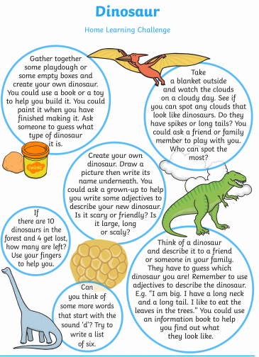
Please have your homework projects in by Monday 27th November, ready to share with the class.

Voluntary Homework

