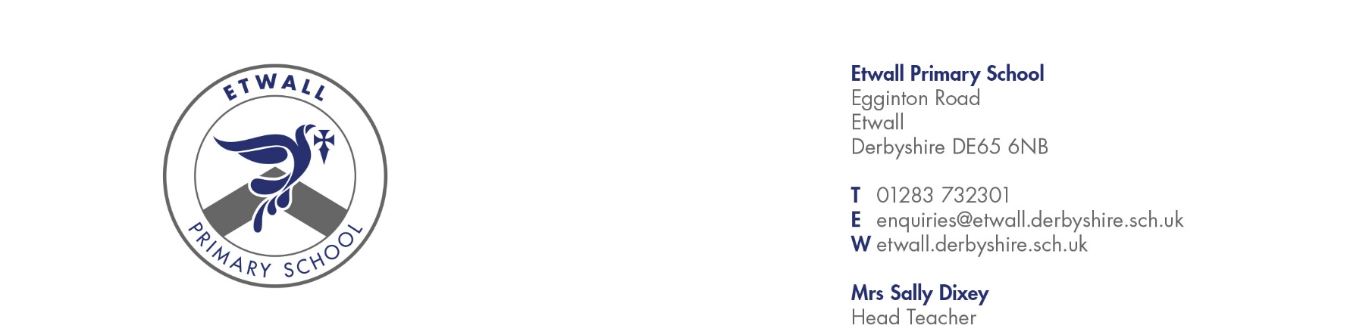

23rd February 2026
Dear Parent/Carer,

Thank you again for kindly agreeing to come into school to talk to the children about your job as part of our Careers Week. Hearing directly from adults in a wide range of professions really helps broaden children’s understanding of the world of work, sparks their curiosity, and encourages them to think about the many opportunities available to them in the future. Medical roles fascinate the children, and hearing directly from someone working in the field makes the experience so meaningful for them.

To help you prepare, here is a little guidance for the session.

On the day, please come to the school office at 2:40pm so that you can sign in and we can show you to the classroom. The class teacher will get the children settled and will then introduce you and explain that we are here to think about jobs in the medical profession and hand straight over to you so that you can talk about your job.

We would be grateful if you could spend a few minutes talking to the children about:

- your role within the medical profession and what you do,
- what a typical day looks like for you,
- who you work with (e.g., doctors, nurses, paramedics, technicians, reception teams),
- how you help people and the kinds of situations you might deal with, and
- the training, skills, or interests that led you into the medical field.

It would be wonderful if you could bring along any safe equipment or items you use at work—such as stethoscopes, bandages, scrubs, gloves, or other non-hazardous tools. These always capture the children’s attention and help them understand your role much more clearly. If you have any photos of your workplace or typical tasks (that don’t include identifiable patients), these are also very helpful.

The children love real-life demonstrations, so if there is a simple, safe activity you can show—such as how you check a patient’s heartbeat, how you apply a bandage or splint, or how certain strategies/tools are used—please feel free to include it.

If your role means that you are unable to bring these things in, please don’t worry! The main thing is to talk about your role and the skills it might involve.

Cont. over

You’ll only need to speak for a few minutes, and the class teacher will be there to support you and to help guide the children’s questions or ask some if they struggle. Do be prepared for a few imaginative questions (and some wriggly bodies, especially with the younger ones). The children are always keen but sometimes very curious in unexpected ways! Equally, some of you may have jobs that the children have never considered and so they might find it more difficult to ask questions. Either is absolutely fine.

Finally, if you could share how children could do this job in the future, that would be great.
- “If you’re good at…”
- “If you enjoy…”
- “You might like this job!”
We want to inspire our children to consider these professions as future career options.

Thank you again for giving up your time to support our Careers Week. We are really looking forward to welcoming you into school and know the children will be excited to learn about the important work you do.

Kind regards,

Sarah Bentley
Headteacher

