Document owner | Etwall Primary School | Signed by Headteacher | 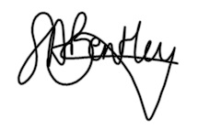
Author: | Sarah Giles
Version: | February 2022 | Next Review | February 2025
This policy has been reviewed on 14/02/2022 and has been impact assessed in the light of all other school policies and the Equality Act 2010.
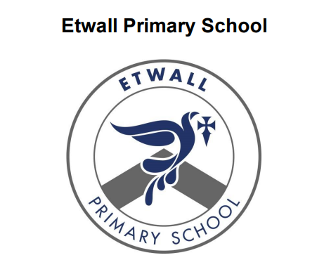

Mental Health and Emotional Wellbeing Policy
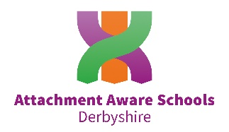
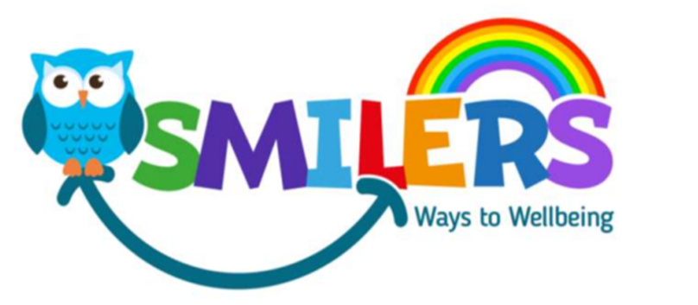

Policy Statement

Mental health is a state of well-being in which every individual realises his or
her own potential, can cope with the normal stresses of life, can work productively
and fruitfully, and is able to make a contribution to her or his community.
(World Health Organization)

At Etwall Primary School, we are committed to supporting the emotional health and wellbeing of our pupils and staff.

We have a supportive and caring ethos and our approach is respectful and kind, where each individual and contribution is valued.

At our school we know that everyone experiences life challenges that can make us vulnerable and at times, anyone may need additional emotional support. We take the view that positive mental health is everybody’s business and that we all have a role to play.

At our school we:

• Help children to understand their emotions and feelings better.
• Help children feel comfortable sharing any concerns or worries.
• Help children socially to form and maintain relationships.
• Promote self-esteem and ensure children know that they count.
- Encourage children to be confident.
• Help children to develop emotional resilience and to manage setbacks.

We promote a mentally healthy environment through:

• Promoting our school values and encouraging a sense of belonging
• Promoting pupil voice and opportunities to participate in decision-making
• Celebrating academic and non-academic achievements
• Providing opportunities to develop a sense of worth through taking responsibility for themselves and others
• Providing opportunities to reflect
• Access to appropriate support that meets their needs

We pursue our aims through:
• Universal, whole school approaches
• Support for pupils going through recent difficulties including bereavement.
• Specialised, targeted approaches aimed at pupils with more complex or long term difficulties including attachment disorder

Scope

This document describes the school’s approach to promoting positive mental health and wellbeing. This policy is intended as guidance for all staff including nonteaching staff and governors.

This policy should be read in conjunction with our Safeguarding, Behaviour, Anti-bullying, PE and PSHCE policies. It should also be read with our medical policy in cases where a student’s mental health overlaps with or is linked to a medical issue and the SEND policy where a student has an identified special educational need.

Lead Members of Staff

Whilst all staff have a responsibility to promote the mental health of students, staff with a specific, relevant remit include:

- Sarah Bentley – Head Teacher, Designated Safeguarding Lead,
- Rick Ormiston – Deputy Head Teacher, Deputy Designated Safeguarding Lead, PE Lead
- Sam Toynbee – Deputy Designated Safeguarding Lead, EYFS Lead, Designated Teacher for Looked After Children
- Sarah Giles – SENCo, Mental Health Lead, Deputy Designated Safeguarding Lead
- Zoe Poynton – School Mental Health and Wellbeing Lead Governor
- Hollie Millward – P.S.H.C.E. Lead, leading on Relationships Education and Health Education
- Nikki Carter – Emotional Literacy Support Assistant (ELSA)/Higher Level Teaching Assistant
- Janice Draper – Positive Play Support Worker/Teaching Assistant

Universal Support
Teaching about Mental Health and Emotional Wellbeing

The skills, knowledge and understanding needed by our pupils to keep themselves mentally healthy and safe are included as part of our PSHE scheme of work PHSE Matters, developed by Derbyshire Health and Wellbeing Consultants. Lessons are taught weekly in a safe and sensitive manner. Additional lessons are sometimes planned, in response to the specific needs of the class/cohort.
In EYFS children follow the PSED strand of the Curriculum.

Assembly themes throughout the year focus on promoting emotional wellbeing.

Worry boxes are established in all classrooms in Key Stage 1 and Key Stage 2 and staff manage children’s worries sensitively on a daily basis.

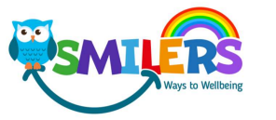
SMILERS was launched in February 2022.

The aim of SMILERS is to empower our school communities (staff and pupils) to become ‘architects’ of their own emotional health and wellbeing within an enabling environment.
SMILERS is adapted from the NHS ‘Five Ways to Mental Wellbeing.’
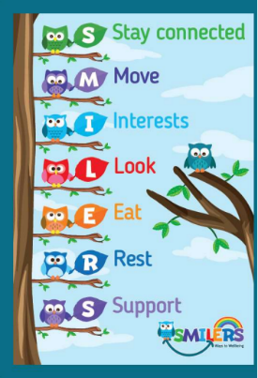

SMILERS help children to develop a ‘toolkit’ of wellbeing activities they can access to support improved emotional wellbeing. It helps children to be better able to self-regulate giving them coping strategies for life.

Anti-Stigma Ambassadors lead and champion mental health and wellbeing in school. They complete training and develop a SMART Action Plan. They share anti-stigma messages with parents and families in the school community supporting others making it easier to talk about mental health without any fear or embarrassment. They run activities in school teaching others how to stay mentally healthy and make displays and posters to share anti-stigma messages.

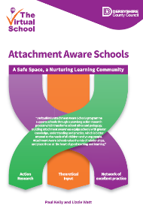
We are an Attachment Aware School (July 2021). The comprehensive programme involved a range of bespoke long-term development work through a dynamic interaction of training, action research and reflective practice to promote a safe, nurturing and effective learning environment. The programme, underpinned by attachment theory and trauma informed, has led the school to become a community of inquiry through a process of practice-as-research, where the cyclical nature of action research enhances the complementary relationship of theory and practice. Building attachment awareness in school, with a focus on relationship building and a better understanding of teacher–pupil interaction, has contributed meaningfully to whole school development. We are committed to understanding children’s behaviour as a means of communication of need, and that relationships in education are the most powerful means to motivate, engage and inspire all of our young learners.

Targeted support
Targeted support is provided for pupils who may have short-term needs and those who may have been made vulnerable by life experiences such as bereavement. The school will offer support through targeted approaches for individual pupils or groups of pupils which may include:
- ELSA Support targeted at individual need
- Positive Play
- Outdoor Nurture
- The ‘Zones of Regulation’ Intervention
- Targeted use of SEAL resources.
- Managing feelings resources e.g. ‘worry boxes’ and ‘worry bag strategy’
- Managing emotions resources such as ‘the incredible 5 point scale’
- Therapeutic activities including art, calm boxes, lego and relaxation and mindfulness techniques.
- Individual timetables
- ‘Meet and Greet’ for pupils that need support with the transition from home to school
The school will make use of resources to assess and track wellbeing as appropriate including:
- The Boxall Profile
- RCADS – Revised Children’s Anxiety and Depression Scale
- SNIP Behaviour Audits
- Emotional literacy rating scales
- Strengths and Difficulties questionnaires

Signposting
We will ensure that staff, pupils and parents are aware of what support is available within our school and how to access further support. What support is available within our school and local community, who it is aimed at and how to access it is outlined in Appendix 2.
We will display relevant sources of support in communal areas such as staff rooms and will regularly highlight sources of support to students within relevant parts of the curriculum. Whenever we highlight sources of support, we will increase the chance of student help-seeking by ensuring students understand:
• What help is available
• Who it is aimed at
• How to access it
• Why to access it
• What is likely to happen next

Identifying needs and Warning Signs
When School staff become aware of warning signs which indicate that a pupil may be experiencing mental health or emotional wellbeing issues, they should record their observations on CPOMS and communicate their concerns with a member of the Safeguarding Team.

Possible warning signs include:
• Irregular attendance and punctuality
• Change in academic progress
• Change in behaviour
• Changes in activity and mood
• Physical health deteriorating
• Repeated physical pain or nausea with no evident cause
• Changes in eating or sleeping habits
• Soiling
• Self-harm/talking or joking about self-harm or suicide
• Expressing feelings of failure, uselessness or loss of hope
• Becoming socially withdrawn/isolating themselves
• Hiding inside clothes (making themselves invisible)
• Attention seeking
• No empathy
• Compulsive lying
• Anxiety

Working with Parents
In order to support parents we will:
• Highlight sources of information and support about mental health and emotional wellbeing on our school website and Class Dojo
• Share and allow parents to access sources of further support e.g. through parent workshops.
• Ensure that all parents are aware of who to talk to, and how to go about this, if they have concerns about their child.
• Make our emotional wellbeing and mental health policy easily accessible to parents
• Share ideas about how parents can support positive mental health in their children.
• Keep parents informed about the mental health topics their children are learning about in PSHE and share ideas for extending and exploring this learning at home.

Working with other agencies and partners
As part of our targeted provision the school will work with other agencies to support children’s emotional health and wellbeing including:
- The school nurse
- Educational psychology services
- Behaviour support
- Paediatricians
- Specialist Community Advisors (SCAs)
- CAMHS (child and adolescent mental health service)
- Counselling services
- Family support workers
- Therapists

Supporting Peers
When a child is suffering from mental health issues, it can be a difficult time for their friends. Friends often want to support but do not know how. In the case of self harm or eating disorders, it is possible that friends may learn unhealthy coping mechanisms from each other. In order to keep peers safe, we will consider on a case by case basis which friends may need additional support. Support will be provided either in one to one or group settings and will be guided by conversations with the child who is suffering and their parents with whom we will discuss:
• What it is helpful for friends to know and what they should not be told
• How friends can best support
• Things friends should avoid doing or saying which may inadvertently cause upset
• Warning signs that their friend may need help (e.g. signs of relapse)
Additionally, we will want to highlight with peers:
• Where and how to access support for themselves
• Safe sources of further information about their friend’s condition
• Healthy ways of coping with the difficult emotions they may be feeling

Training
Staff will receive regular training about recognising and responding to mental health issues as part of their regular child protection training in order to enable them to keep students safe, as well as information about the range of services available to support children and families facing mental health challenges.
The MindEd learning portal provides free online training suitable for staff wishing to know more about a specific issue.
https://www.minded.org.uk/

The Derbyshire Emotional Health and Wellbeing Site website also provides a wide range of information for school staff.
https://derbyandderbyshireemotionalhealthandwellbeing.uk/
Training opportunities for staff who require more in depth knowledge will be considered as part of our performance management process and additional CPD will be supported throughout the year where it becomes appropriate due to developing situations with one or more pupils.

Policy Review
This policy will be reviewed every year for the next two years as the school grows in its mental health growth and development and then every 3 years as a minimum. It is next due for review in February 2023.

Appendix 1 Whole school Approach Model - Pathway of support
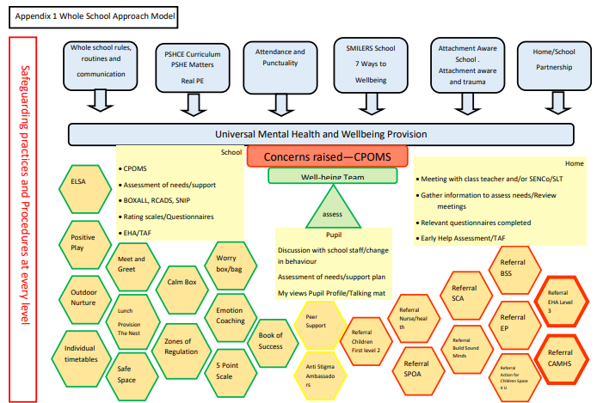
Appendix 2
Sources of Information Advice and Guidance
Space 4 U is a service for children and young people aged 5-18 years who are seriously affected by someone else’s substance misuse, i.e. drugs and / or alcohol. This could be a parent, sibling or close friend. The substance use can be current or previous. Having emotional support can give a child / young person the opportunity and space to talk about their feelings
Contact Details: 01246 277422
space.4u2@actionforchildren.org.uk

Build Sound Minds Derby & Derbyshire Short term early intervention mental health support for children 0-17 Mild to moderate mental health difficulties that do not meet the thresholds for more specialist services – low mood, anxiety, simple phobias, stress, worry, low level self harm – not suitable for children on CAMHS waiting list. Referral criteria: https://services.actionforchildren.org.uk/derbyshire/build-sound-minds/make-a-referral/ Build resilience and prevent more serious mental health issues developing. Short term work – 6-8 weeks – not longer term counselling.

Action for Children - Fab Group and Families Moving Forward Group - Feelings Affect Behaviour (FAB) FAB is an intervention dedicated to parents and primary caregivers of primary school aged children. Research tells us that the most effective way to support the emotional well-being of children under the age of 12 years, is through working therapeutically with parents and/or primary caregivers. The course aims to help parents and primary caregivers to understand their child’s needs, particularly focusing on stages of child development, parent-child relationships and brain-based parenting approaches. FAB is delivered over 6 weeks, each session lasting for an hour. Visit our website: www.actionforchildren.org.uk Call our friendly team: Derby City/South Derbyshire: 01332 679379 North Derbyshire: 01246 277422 Email us: afcbsmdd.bsm.dd@nhs.net

Digital Offer: Lumi Nova This digital game has been developed to support children aged between 7 and 12 years who are experiencing anxiety or worry. The game is based on ‘Exposure Therapy’, where a child is gradually exposed to a worry and learns strategies to cope with this. It is well validated and is gaining a good evidence base for the reduction of childhood anxiety. Children will need access to a mobile phone, tablet or laptop to engage with Lumi Nova. For more information on Lumi Nova visit: https://www.bfb-labs.com/lumi Call our friendly team: Derby City/South Derbyshire: 01332 679379 North Derbyshire: 01246 277422 Email us: afcbsmdd.bsm.dd@nhs.net

Derbyshire & Derbyshire Emotional Well Being is a portal to a wide range of other services. Click on the link to find out more https://derbyandderbyshireemotionalhealthandwellbeing.uk/

Action for Children - Browse articles on the most common parenting questions from our experts. Or talk one-to-one with a qualified parenting coach about anything that’s worrying you. Click on the link to find out more: https://www.parents.actionforchildren.org.uk/
Action for Children - ask your question in the chat box and one of our parenting coaches will respond as soon as they are free. Click on the link to find out more: https://shr.actionforchildren.org.uk/
Derbyshire Federation for Mental Health are a specialist mental health support service charity with a strong service user focus and high professional standards. Click on the link to find out more: https://www.dfmh.co.uk/
Mind are a national charity providing help and support to anyone with a mental health problem. Click on the link to find out more: https://www.mind.org.uk/
Young Minds provide young people with the tools to look after their mental health. Click on the link to find out more: https://youngminds.org.uk/
Kooth is an online community for mental health and wellbeing. Click on the link to find out more: https://www.kooth.com/
Daisy Chain offer a telephone service to enable families to access advice, support and resources. They provide support and services for those who display traits associated with autism spectrum disorder (ASD), sensory processing differences, and attention deficit hyperactivity disorder (ADHD). Click on the link to find out more: https://www.daisychainproject.co.uk/
Think Ninja is a mental health app designed for 10 to 18 year olds. Using a variety of content and tools, it allows young people to learn about mental health and emotional wellbeing, and develop skills they can use to build resilience and stay well. Click on the link to find out more: https://www.nhs.uk/apps-library/thinkninja/
First Steps ED work across the Midlands, providing care and support for children and their families, young people and adults affected by eating difficulties and disorder. Click on the link to find out more: https://firststepsed.co.uk/about-us/
The Laura Centre is a professional bereavement service. They have a mixture of qualified counsellors and trained visiting counsellors. Click on the link to find out more https://thelauracentre.org.uk/
Winston’s Wish provides emotional and practical bereavement support to children, young people and those who care for them. Click on the link to find out more https://www.winstonswish.org/
Shout 85258 is a free, confidential, 24/7 text messaging support service for anyone who is struggling to cope. Click on the link to find out more https://giveusashout.org/
Childline is here to help anyone under 19 in the UK with any issue they’re going through. You can talk about anything. Whether it’s something big or small, trained counsellors are here to support you. Click on the link to find out more https://www.childline.org.uk/toolbox/calm-zone/
Umbrella support children and young people aged 5 to 30 with any additional needs, including physical, sensory, learning and behavioural disabilities. Click on the link to find out more: https://umbrella.uk.net/
Calm Harm is a free app to help manage self harm urges. Click on the link to find out more: https://calmharm.co.uk/
Papyrus provide confidential support and advice to young people struggling with thoughts of suicide, and anyone worried about a young person through a helpline. Click on the link to find out more: https://www.papyrus-uk.org/
National Autistic Society provides help and support to autistic people and their families. Click on the link to find out more: https://www.autism.org.uk/
Safe and Sound are tackling child sexual exploitation by providing high quality tailored one-to-one support to victims and young people at risk in Derby and Derbyshire. Click on the link to find out more: https://www.safeandsoundgroup.org.uk/
Enthusiasm provide dedicated youth work mentors to support a minimum of 60 young people aged 11-18 who are most at risk of exclusion from education, offending and anti-social behaviour. Click on the link to find out more: https://enthusiasm.org.uk/about-us/derby/
The Education Support Partnership – Supporting the mental health and wellbeing for teachers and education staff. They offer a 24 hour free and confidential helpline. https://www.educationsupport.org.uk/

DFE RSHE Mental Wellbeing Training Module
MENTAL HEALTH TRAINING MODULE
Teaching about mental wellbeing - GOV.UK (www.gov.uk)
PSHE Association: Guidance on Teaching Mental Health and Wellbeing in PSHE
PSHE ASSOCIATION MENTAL HEALTH GUIDANCE

Mental Health First Aid/ Awareness/ Suicide Prevention
Funded by Public Health Derbyshire
https://www.derbyshire.gov.uk/social-health/health-and-wellbeing/mental-health-and-wellbeing/mental-health-training/mental-health-training.aspx
Training and Signposting Funded by DDCCG
https://derbyandderbyshireemotionalhealthandwellbeing.uk/
E-Learning Modules
https://www.minded.org.uk/
DFE Guidance June 2021
Promoting and supporting mental health and wellbeing in schools and colleges
Find out what help you can get to develop a whole school or college approach to mental health and wellbeing.
Promoting and supporting mental health and wellbeing in schools and colleges - GOV.UK (www.gov.uk)
Mental health resources for teachers and teaching staff (publishing.service.gov.uk)

