Document owner | Etwall Primary School | Signed by Headteacher
Author: | Tiz Bradley  Claire Leggett  Linz Cox
Version: | February 2021 | Next Review | February 2023

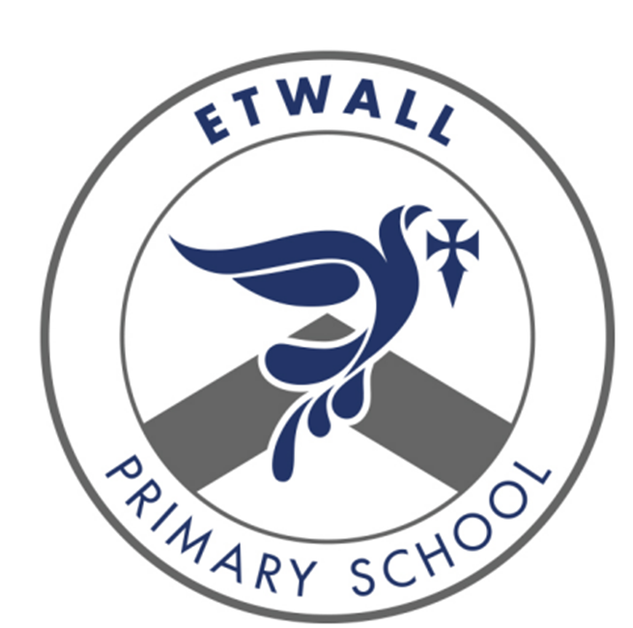

Maths
Intent, Implementation
and Impact

Intent

At Etwall Primary School, we believe an ambitious and rich mathematics curriculum is an important part of children’s development throughout school, right from an early age. We intend on delivering a curriculum which:
- Allows children to become fluent in the fundamentals of mathematics through creative and engaging lessons that give them a range of opportunities to explore mathematics.
- Develops conceptual understanding and the ability to recall and apply knowledge fluently and rapidly.
- Gives children opportunities to reason and problem solve by applying mathematics to a variety of increasingly complex challenges.
- Ensures children believe in themselves as mathematicians, and develop resilience and perseverance that enables all children to reason and problem solve with increased confidence.
- Builds upon children’s knowledge and understanding from EYFS to Year 6, and is in line with the Early Learning Goals and the National Curriculum.

Curriculum Implementation

Our mastery approach to the curriculum is designed to develop children’s knowledge and understanding of mathematical concepts from the Early Years through to the end of Year 6.

- In school, we follow the National Curriculum and use the White Rose Scheme of Work as a guide to support teachers with their planning. This creates continuity and progression in the teaching of mathematics.
- The calculation policy is used within school to ensure a consistent approach to teaching the four operations over time.
- Daily maths lessons include fluency, reasoning and problem solving.
- Concrete manipulatives and pictorial representations are used to support conceptual understanding and to make links across topics.
- Lessons start with an engaging question for children to discuss and share, and the learning within that lesson builds up the skills to enable children to answer this question.
- Key vocabulary is introduced and revisited regularly to develop language acquisition.
- Children who have shown understanding at a deep level are given challenges with deeper knowledge questions or activities to develop their skills further.
- Children with additional needs are included in whole class lessons and teachers provide scaffolding and relevant support as necessary.
- Children have access to Maths Shed, Times Tables Rock Stars and Numbots both in and out of school to practise core skills.
- Feedback is given in line with our feedback policy.
- Formative assessment occurs within every lesson to help identify the children who need more support to achieve the intended outcome and who are ready for greater challenges.
- Summative assessments are completed at the end of each term, to inform the gaps in learning which can be filled in following lessons. These also help to create a clear picture of the progress of children within the school.

Impact

A mathematical concept or skill has been mastered when a child can show it in multiple ways, using the mathematical language to explain their ideas, and can independently apply the concept to new problems in unfamiliar situations. We aim for mastery in maths for all children.

Through this approach, children will have:

- Quick recall of facts and procedures
- The flexibility and fluidity to move between different contexts and representations of mathematics.
- The ability to reason and problem solve in different areas of mathematics.
- The ability to recognise relationships and make connections in mathematics.
- Resilience in the face of new challenges and concepts.
Standards will be monitored by the subject lead and SMT through:
- Learning discussions with both children and teachers
- Scrutiny of books and outcomes
- Observation of practice
- Termly assessments

This information will be used to evaluate the effectiveness of subject plans and subject practice. The impact on whole school learning and teaching will be used to inform the school improvement plan.

Skills Progression

Teachers have identified the key knowledge and skills to be taught in each blocked topic and consideration has been given to ensure progression across topics throughout each year group across the school. See Appendix 1 for Maths skills progression.

Assessment

Assessment for learning is continuous throughout the planning, teaching and learning cycle. Key mathematical skills are taught to enable and promote the development of children’s mathematical understanding. Teachers track the children’s acquisition and application of key skills through varied fluency, reasoning and problem-solving approaches.

Assessment is also supported by use of the following strategies:

- Observing children at work, individually, in pairs, in a group and in class during whole class teaching.
- Using differentiated, open-ended questions that require children to explain and unpick their understanding.
- Providing effective feedback, including interactive marking through next steps questions, where appropriate, to engage children with their learning and to provide opportunities for self-assessment, consolidation, depth and target setting.
- Book moderation and monitoring of outcomes of work, to evaluate the range and balance of work and to ensure that tasks meet the needs of different learners, with the acquisition of the pre-identified key knowledge of each topic being evidenced through the outcomes.

At the end of each term, NFER and NTS tests are used and the strengths/areas for development are shared with the Senior Leaders. Standardised scores are tracked to ensure that teachers use assessments to inform their planning.

National Curriculum tests are used at the end of KS1 and KS2; teachers use past and sample papers to inform their assessments as they prepare pupils for these assessments. Year Four pupils will also undertake the National Multiplication Tables Check. Each child’s attainment and progress in mathematics is formally reported to parents at the end of each term.

Early Years

‘Every child deserves the best possible start in life and the support that enables them to fulfil their potential.’ (Statutory framework for the early years foundation stage)

Mathematics is one of the areas of learning and development set out in the statutory framework for the Early Years. The EYFS Framework in relation to mathematics aims for our pupils to:

    - develop and improve their skills in counting
    - understand and use numbers
    - calculate simple addition and subtraction problems
    - describe shapes, spaces, and measures

At Etwall Primary, we have a firm belief in the acquisition of number skills which will enable children to use their deep learning in order to perform simple skill with numbers and to reason about numbers. They will be able to use their number skills to solve simple problems.

The statutory framework states:

ELG Number: Children at the expected level of development will: - Have a deep understanding of number to 10, including the composition of each number; Subitise (recognise quantities without counting) up to 5; Automatically recall (without reference to rhymes, counting or other aids) number bonds up to 5 (including subtraction facts) and some number bonds to 10, including double facts.

‘Numbers: children count reliably with numbers from 1 to 20, place them in order and say which number is one more or one less than a given number. Using quantities and objects, they add and subtract two single-digit numbers and count on or back to find the answer. They solve problems, including doubling, halving and sharing.’ For this reason, we teach the children their numbers in stages, beginning with a focus on numbers to five. Children will understand the sequence of numbers, how to count up and down in steps of one, how to match them to their respective amounts, one more than and one less than, recognising an amount without counting to five quickly (known as subitising) Children will use a variety of apparatus to achieve this including everyday objects, counters, dice, cubes, number frames (ten frames) Numicon, pictures, and number tracks.

ELG: Numerical Patterns: Children at the expected level of development will: - Verbally count beyond 20, recognising the pattern of the counting system; - Compare quantities up to 10 in different contexts, recognising when one quantity is greater than, less than or the same as the other quantity; - Explore and represent patterns within numbers up to 10, including evens and odds, double facts and how quantities can be distributed equally.

The framework continues: ‘Shape, space and measures: children use everyday language to talk about size, weight, capacity, position, distance, time and money to compare quantities and objects and to solve problems. They recognise, create and describe patterns. They explore characteristics of everyday objects and shapes and use mathematical language to describe them.’ Through a rich, varied enquiry approach with child-initiated learning, children will explore everyday objects and contexts to support shape, space and measures and will be taught the language of these concepts.

SMSC Development

Spiritual development in mathematics
The study of mathematics enables pupils to make sense of the world around them and we strive to enable each of our pupils to explore the connections between their numeracy skills and every-day life. Developing deep thinking and an ability to question the way in which the world works promotes the spiritual growth of pupils. Pupils are encouraged to see the sequences, patterns, symmetry and scale both in the man-made and the natural world and to use maths as a tool to explore it more fully.

Moral development in mathematics
The moral development of pupils is an important thread running through the mathematics curriculum. Pupils are provided with opportunities to use their maths skills in real life contexts, applying and exploring the skills required in solving various problems. All pupils are made aware of the fact that the choices they make lead to various consequences. They must then make a choice that relates to the result they are looking for. The logical aspect of this relates strongly to the right/wrong responses in maths.

Social development in mathematics
Problem solving skills and teamwork are fundamental to mathematics through creative thinking, discussion, explaining and presenting ideas. Pupils are always encouraged to explain concepts to each other and support each other in their learning. In this manner, pupils realise their own strengths and feel a sense of achievement which often boosts confidence. Over time they become more independent and resilient learners.

Cultural development in mathematics
Mathematics is a universal language with a myriad of cultural inputs throughout the ages. Various approaches to mathematics from around the world are used and this provides an opportunity to discuss their origins. We try to develop an awareness of both the history of maths alongside the realisation that many topics we still learn today have travelled across the world and are used internationally.

Diversity

Through mathematics, children learn about the diversity of national, regional, religious and ethnic identities; teachers encourage pupils to think about topical political, spiritual, moral, social and cultural issues, problems and events and to use their imagination to consider other people's experiences.

Equal Opportunities

At Etwall Primary, we are committed to providing a teaching environment which ensures all children are provided with the same learning opportunities regardless of social class, gender, culture, race, special educational need or disability. Teachers use a range of strategies to ensure inclusion. Support for specific individuals is well considered and planned for, with consideration given to how greater depth and further challenge can be implemented.

Inclusion

All pupils are entitled to access the mathematics curriculum at a level appropriate to their needs. Mathematics forms part of the school curriculum policy to provide a broad and balanced education to all children. Through our mathematics teaching, we provide learning opportunities that enable all pupils to make good progress. We strive hard to meet the needs of those pupils with special educational needs, those with disabilities, those who are gifted and talented and those learning English as an additional language, and we take all reasonable steps to achieve this. To ensure inclusion, teachers use a range of strategies. Independent tasks, as well as teaching, are also well-adapted to ensure full accessibility, as well as to provide appropriate challenge to different groups of learners. The school makes full use of additional adults who are deployed effectively to ensure that identified children can make progress in each curriculum area, according to their full potential.

Health and Safety

The curriculum will be delivered in a safe and healthy manner; every effort will be taken to identify risks associated with a curriculum subject/activity and the appropriate control measures will be implemented. Pupils will be educated about health and safety issues as and when the opportunity arises throughout the course of normal teaching.

