WRITING
Practice writing their names correctly, using a capital letter for the first letter only.
The most appropriate pencil grip is the ‘tripod grip’ which allows both control and fluid movement.
If your child finds it difficult to hold a thin pencil it may be worth trying a triangular pencil or a pencil grip which are designed to encourage a tripod grip.
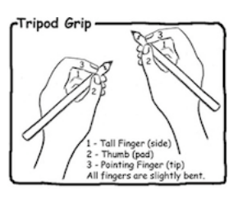

Encourage your child to take care with their letter formation and presentation. Practice letter formation and joins on the lined paper, using the phoneme charts as a reference. Encourage them to leave spaces between words to support the development of whole word awareness.
