Document owner | Etwall Primary School | Signed by Headteacher | 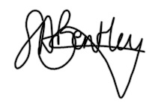
Author: | Sarah Giles
Version: | March 2022 | Next Review | March 2025
This policy has been reviewed on 10/03/2022 and has been impact assessed in the light of all other school policies and the Equality Act 2010.

Child-Friendly Mental Health and Emotional Wellbeing Policy

Contents
Mental Health and Wellbeing
- What does it mean?
- Who can we talk to?
- How does our school teach us about mental health and wellbeing?
- How do we know when we are not OK?
- What can we do to look after our own mental health?
- How can we help our friends and other children in our school?
- What can we do if we need further support?

Mental Health and Emotional Wellbeing

At Etwall Primary School, we promise to help you understand your emotions and feelings better so you can be happy and confident in school. This policy has been written by the Anti-Stigma Ambassadors to show you how you can help your own emotional wellbeing and ensure you feel comfortable sharing any worries or concerns. This policy also, signposts you to where you can access further support if you need to.

It is important to remember that we all go through life’s ‘ups and downs’ and at times this can be overwhelming. It is OK to ask for help and have a little more emotional support when we need it.

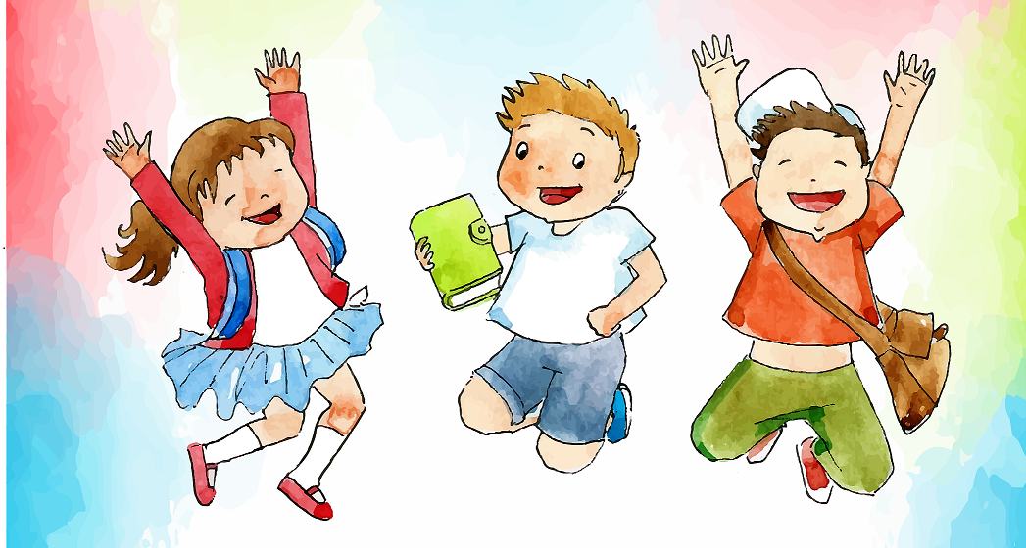

- What does it mean?
We all have Physical and Mental Health.
Important Fact: The body and mind are connected.
If we are struggling with our physical health this can affect how we feel = our mental health.
If we are struggling with our mental health this can also affect our bodies = our physical health.
By looking after our Mental Health and Physical Health we can improve how we feel = wellbeing.
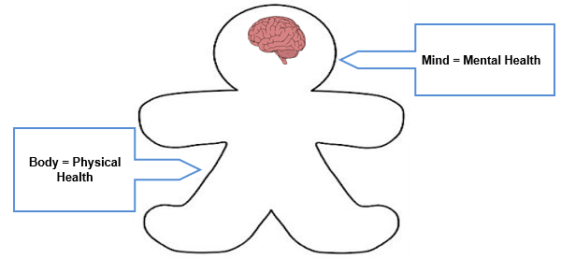

Mental wellbeing is about feeling good. Feeling that life is going well, and feeling able to get on with everyday things.
To be able to deal with life’s ups and downs; to be able to learn; enjoy friendships; to meet challenges and to develop talents and capabilities.

Everyday Feelings
We all have lots of feelings that come and go everyday.
For example, feeling excited about a present; nervous about going back to school or frustrated because you missed a penalty.
Everyday feelings can feel very strong and intense at times, they can feel uncomfortable sometimes but this is normal for everyone.

Big Feelings
Big feelings can change how we think, feel and behave, how we see the world and how we get on with other people. They can affect our mental health and can be really serious for some people, they can make someone feel lonely or overwhelmed by the feeling.
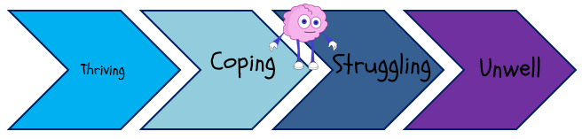

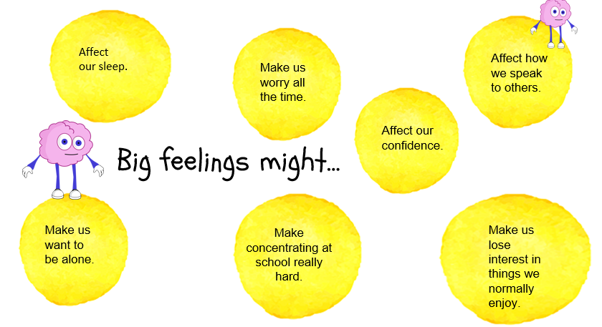

- Who can we talk to?
Remember if your feelings are getting too big to cope with on your own and you feel you want to change things…

…talking to someone you trust might really help.
This could be:
- The Headteacher
- A teacher
- Your parents
- Another member of staff
- Anti-Stigma Ambassadors

- How does our school teach us about mental health and wellbeing?

At Etwall Primary school, we have weekly PSHE lessons. Topics include exploring our emotions and being healthy which covers both physical and mental health.
We have PE lessons at least twice a week. As part of the REAL PE Curriculum, we learn about the importance of being healthy and staying fit.

We have assemblies throughout the year, which focus on emotional wellbeing.
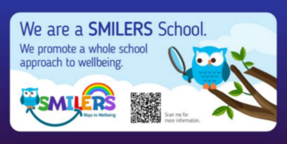
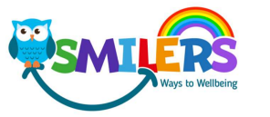
We are a SMILERS School

Have you ever heard of the 5 ways to wellbeing?

The Five Ways to Wellbeing are some simple little things, we can choose to do every day to help with our wellbeing. This can make us feel happier and cope better with daily life and the challenges we all face.

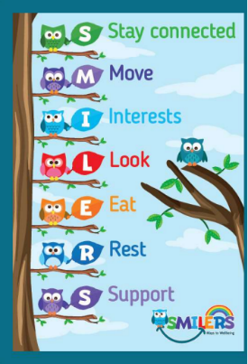
SMILERS have used the Five Ways to Wellbeing and adapted it, so it is easier to remember and have added two other areas, which are also important to maintain good wellbeing and these seven ways to wellbeing are called SMILERS.
Etwall Primary School launched SMILERS in March 2022 and the Anti-Stigma Ambassadors plan wellbeing activities throughout the year to keep SMILERS alive.

Anti-Stigma Ambassadors lead and champion mental health and wellbeing in school. They run activities in school teaching their peers how to stay mentally healthy and make displays and posters to share anti-stigma messages.

In school, we also have ELSA, Positive Play and Outdoor Nurture support if we need it. We sometimes do the ‘Zones of Regulation’ intervention and every class has a SMILERs station and worry box.

- How do we know when we are not OK?
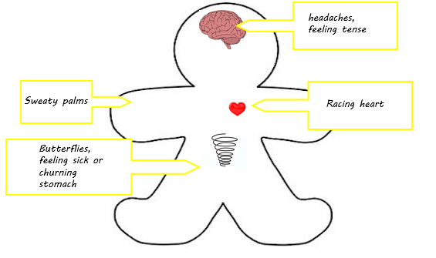

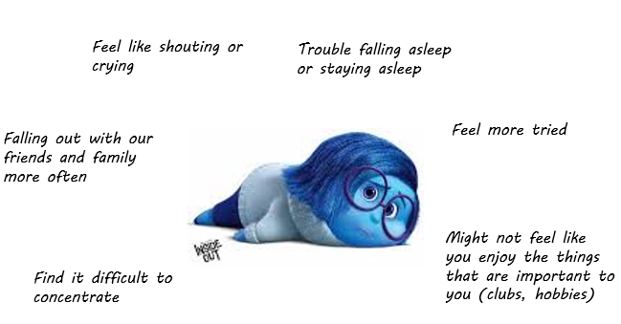
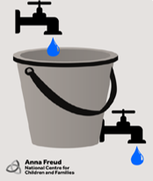
Lots of different things can make us feel stressed. Too much stress can cause our stress bucket to overflow.

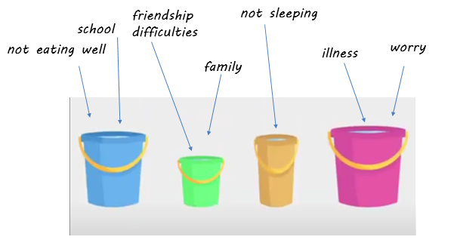
What could fill a stress bucket?

- What can we do to look after our own mental health?

Ways to manage our stress bucket.
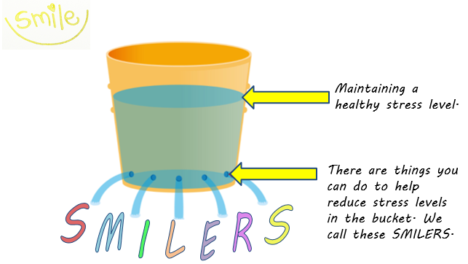

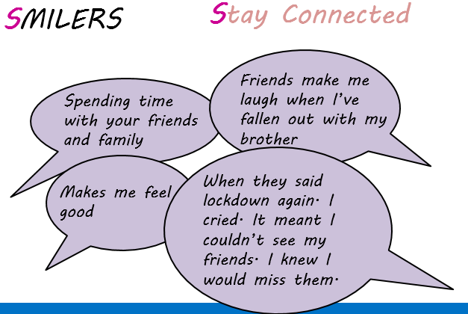
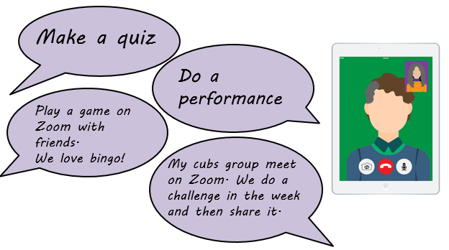
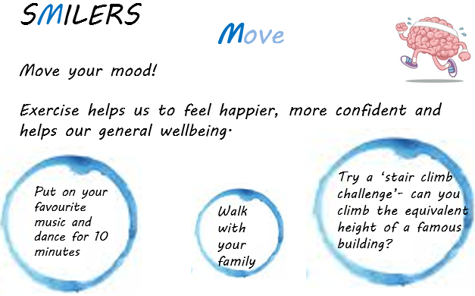

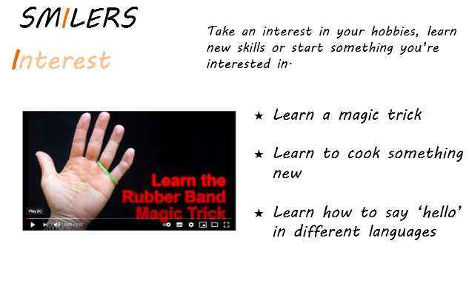

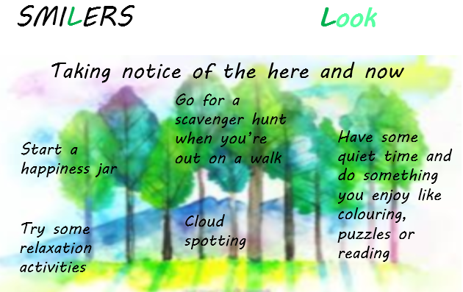

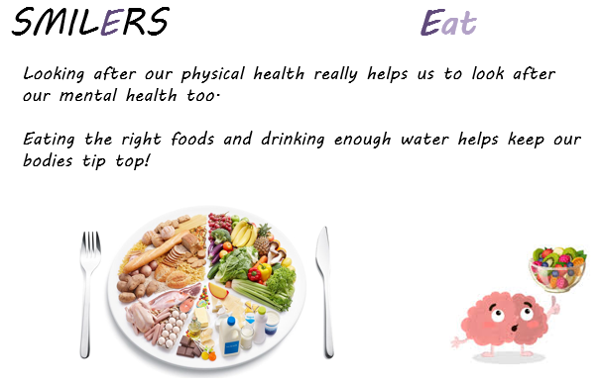

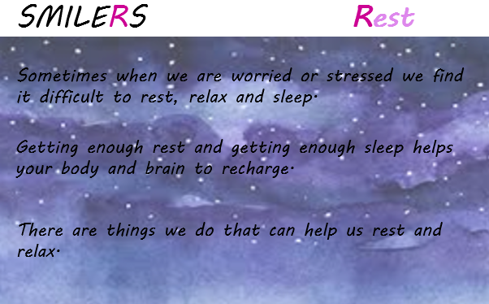

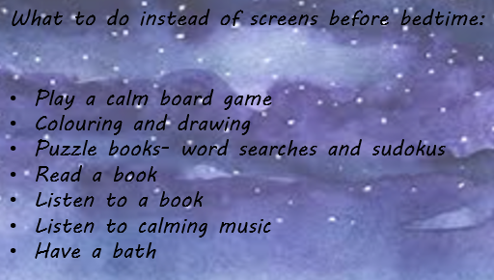
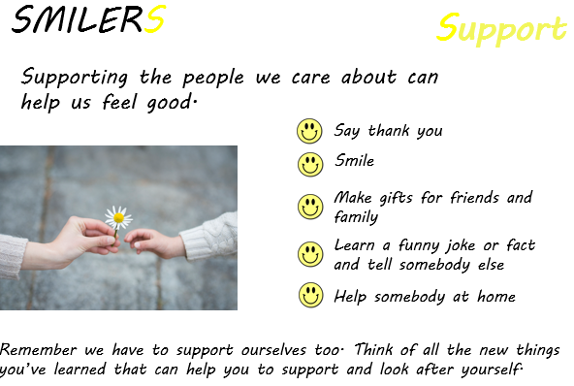

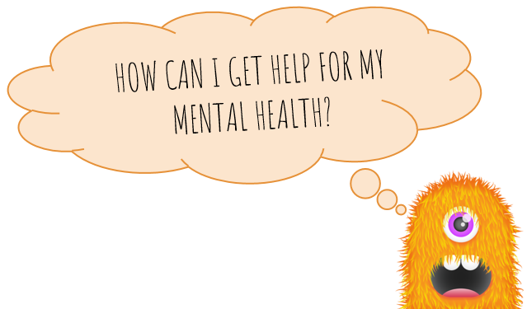

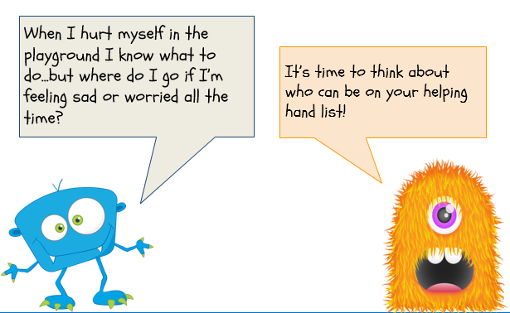

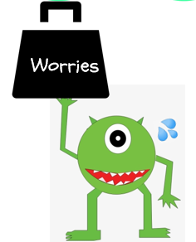
Our worries can sometimes feel really big and they weigh us down.
Or we might think our worries are really silly. This can make us feel like someone wouldn’t understand them.
But if we keep our worries to ourselves they can get bigger and heavier.

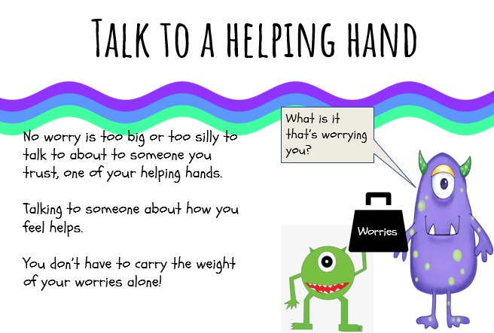

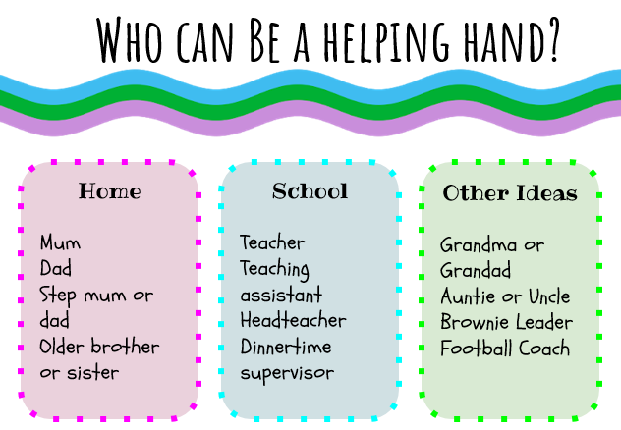

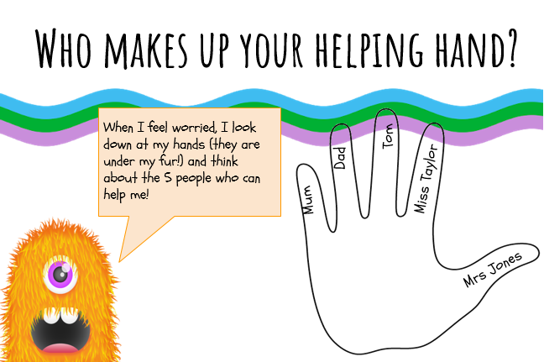

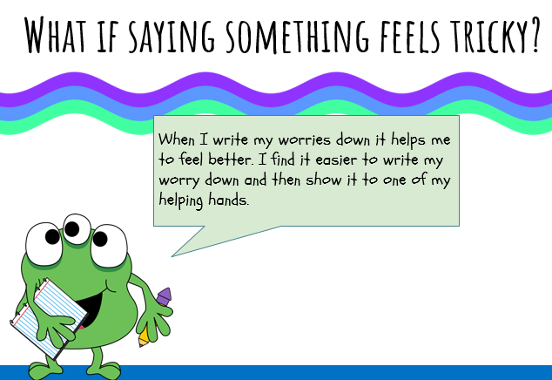

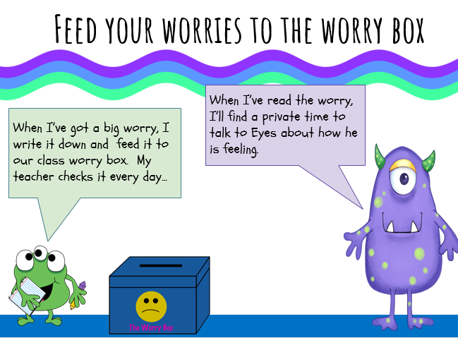

- How can we help our friends and other children in our school?

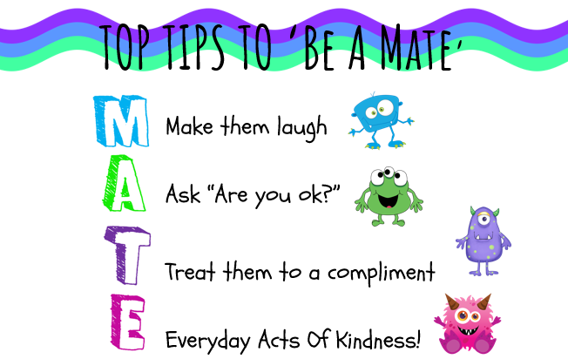
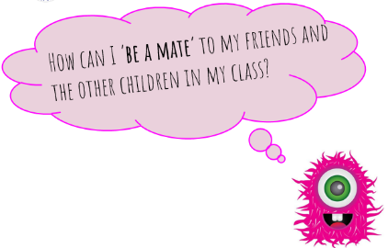

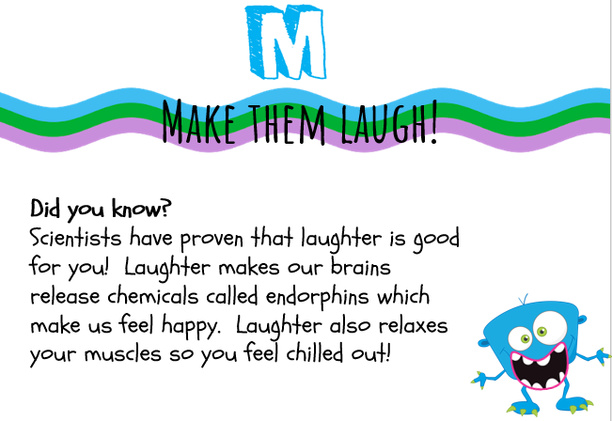

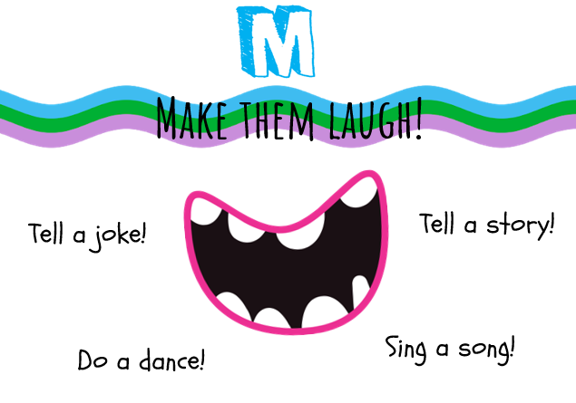

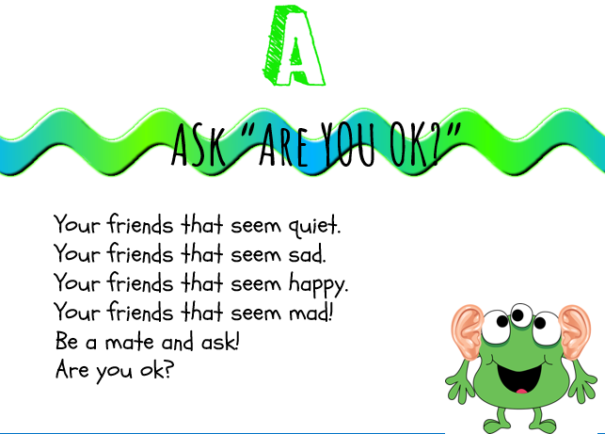

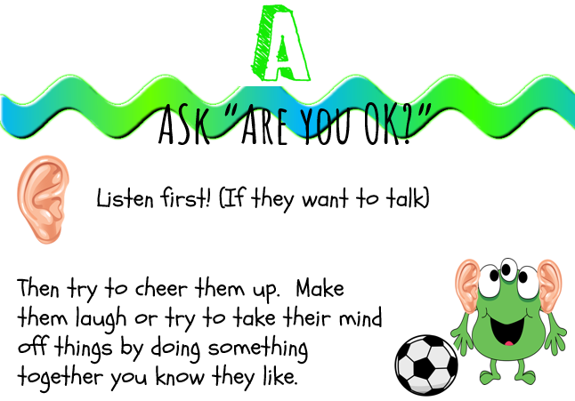

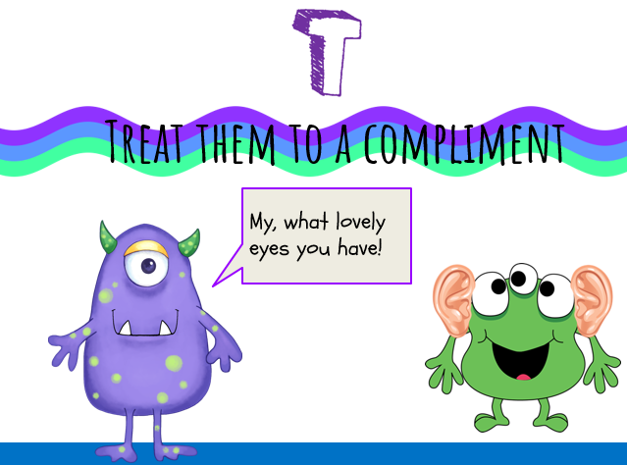

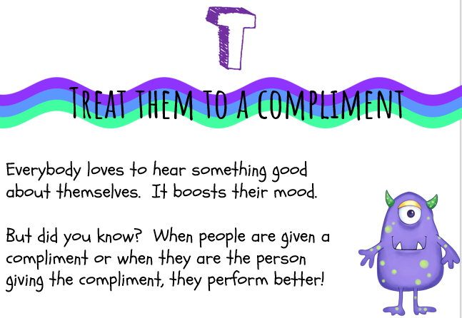

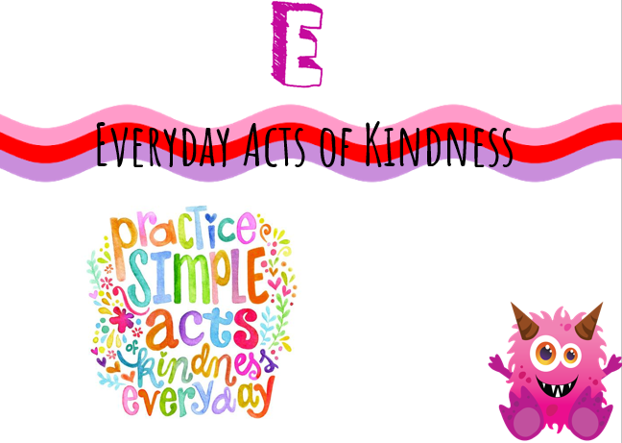

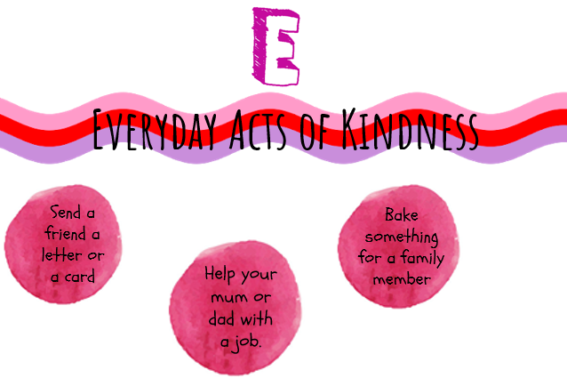

We could try these ideas in school.
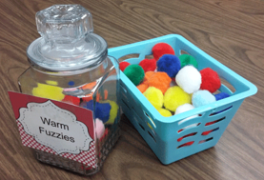
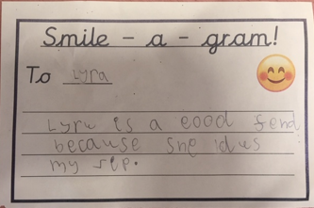

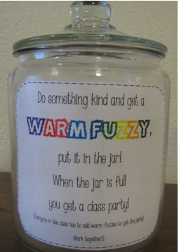

- What can we do if we need further support?

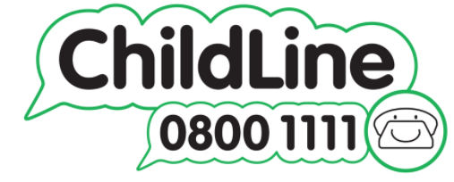
ChildLine is a free, private and confidential service where you can talk about anything.
https://www.childline.org.uk/about/about-childline/

YOUNGMINDS provide young people with tools to look after their mental health. Their website is full of advice and information on what to do if you're struggling with how you feel. They give young people the space and confidence to get their voices heard and change the world they live in. Together, their vision is to create a world where no young person feels alone with their mental health.
https://www.youngminds.org.uk/

