Y1/2 Homework Booklet – Spring 1

In KS1, children are expected to complete the following homework tasks every week to support their development in the core subjects. Thank you for your support in helping your child.
Reading
Please listen to your child read and ask them questions to support their comprehension of the text. Record any reading/discussion that you do in your child’s reading diary for their class teacher to see.
Children are expected to read outside of school a minimum of five times a week. Diaries are checked in class weekly.

Spelling
Y2: Your child will have a spelling list to learn every week. These will be sent home on a spelling sheet and be on the class webpage. Your child will not be given spellings to learn over half term breaks, in line with our homework policy. Y1: Please help your child to practise reading the phonemes that they are learning in phonics each week. (See section overleaf.)

Voluntary Homework
Please see overleaf for homework project ideas for you to complete with your child based on this terms topics.

Please note this is extra voluntary homework and not in place on reading, spellings and times-tables practise.
Times –Tables and division facts
By the end of Y2, children are expected to be fluent in their 2x, 5x and 10x tables and their related division facts (e.g. if 2 x 5 = 10, then 10 ÷ 2 = 5)
Please practise these at least 5 times per week, but preferably daily.

Y1/2 common exception words
Although we teach children phonics to help them to accurately read and spell words using the phonics rules, we also need to teach the children the grapheme-phoneme correspondences that do not fit in with these rules (otherwise known as common exception rules). Please help your child to learn to read/spell these words accurately.

Year 1 common exception words

the
a do
to today
of said
says are
were was
is his
has I
you your
they be
he me
she we
no go
so by
my here
there where
love come
some one
once ask
friend school
put push
pull full
house our.

Year 2 common exception words
door floor Mr
poor because Mrs
find kind parents
mind behind Christmas
child children
wild climb
most only
both old
cold gold
hold told
every everybody
even great
break steak
pretty beautiful
after fast
last past
father class
grass pass
plant path
bath hour
move prove
improve sure
sugar eye
could should
would who
whole any
many clothes
busy people
water again
half money

Times Tables
2 x
2 x 1 = 2
2 x 2 = 4
2 x 3 = 6
2 x 4 = 8
2 x 5 = 10
2 x 6 = 12
2 x 7 = 14
2 x 8 = 16
2 x 9 = 18
2 x 10 = 20
2 x 11 = 22
2 x 12 = 24
5 x
5 x 1 = 5
5 x 2 = 10
5 x 3 = 15
5 x 4 = 20
5 x 5 = 25
5 x 6 = 30
5 x 7 = 35
5 x 8 = 40
5 x 9 = 45
5 x 10 = 50
5 x 11 = 55
5 x 12 = 60

10 x
10 x 1 = 10
10 x 2 = 20
10 x 3 = 30
10 x 4 = 40
10 x 5 = 50
10 x 6 = 60
10 x 7 = 70
10 x 8 = 80
10 x 9 = 90
10 x 10 = 100
10 x 11 = 110
10 x 12 = 120

Phonics: weekly phonemes

 | Mrs Swan’s group | Mrs Milward’s group | Miss Cox’s group
Week 1 | Adding s and es | Alternative spellings for c – k, ck, qu, x, ch | Alternative spellings for c – k, ck, qu, x, ch
Week 2 | Adding ed, ing, er and est to words ending in y | Alternative spellings for ch – tch and  f – ff, ph | Alternative spellings for ch – tch and  f – ff, ph
Week 3 | Adding s and es to words ending in y | Alternative spellings for j – g, dge and  m - mb | Alternative spellings for j – g, dge and  m - mb
Week 4 | Words ending in ful and less | Alternative spellings for n – kn, gn and  ng - nk | Alternative spellings for n – kn, gn and  ng - nk
Week 5 | Words ending in ment and ness | Alternative spellings for r – wr  s – c and sc | Alternative spellings for r – wr  s – c and sc
Week 6 | Words ending in ly | Alternative spellings for sh – ch, t(ion), ss(ion, ure), s(ion, ure), c(ion, ious, ial) | Alternative spellings for sh – ch, t(ion), ss(ion, ure), s(ion, ure), c(ion, ious, ial)

Buildings in Etwall
If you choose to do this piece of homework, please have your homework projects in by the middle of the last week of this term.

As part of our topic ‘Buildings in Etwall’ we be looking at the buildings in Etwall and thinking about the materials that they are made from. We will be testing materials for different properties, looking at how modern houses differ from past houses and much more.
Your challenge is to create a project all about the buildings in Etwall. This could be through a fact file, a collage, a model, a powerpoint presentation or even a video blog. These are just some of the many ideas for a project on ‘Buildings in Etwall.’
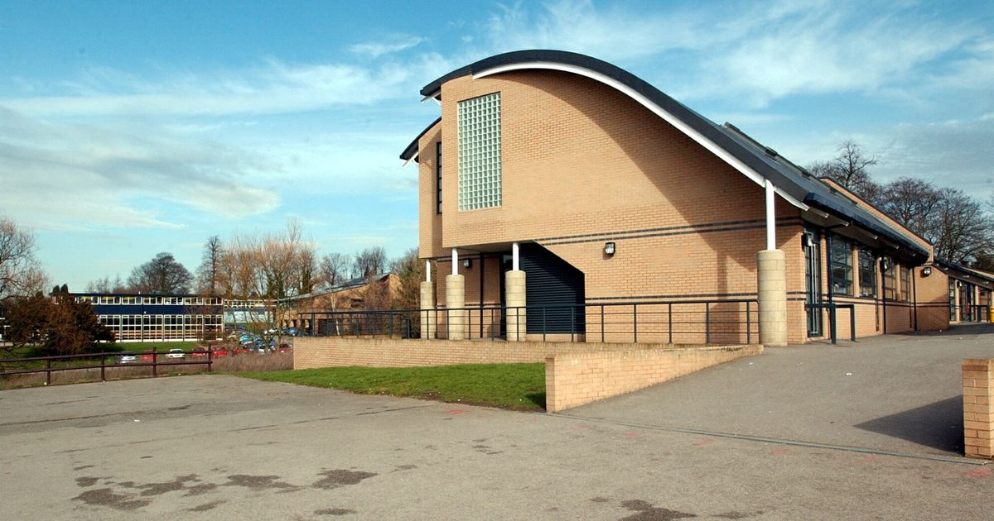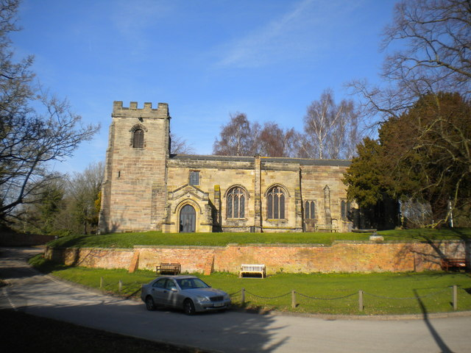
Need help with how to set out this project? Please ask your child’s class teacher!
This half-terms homework challenge is to learn all about…

Voluntary Homework

