Document owner | Etwall Primary School | Approved by:
Author: | Claire Leggett, Lindsey Cox and Elizabeth Bradley | Headteacher
Version: | April 2022 | Next Review | April 2024
This policy has been reviewed on 29/04/2022 and has been impact assessed in the light of all other school policies and the Equality Act 2010.

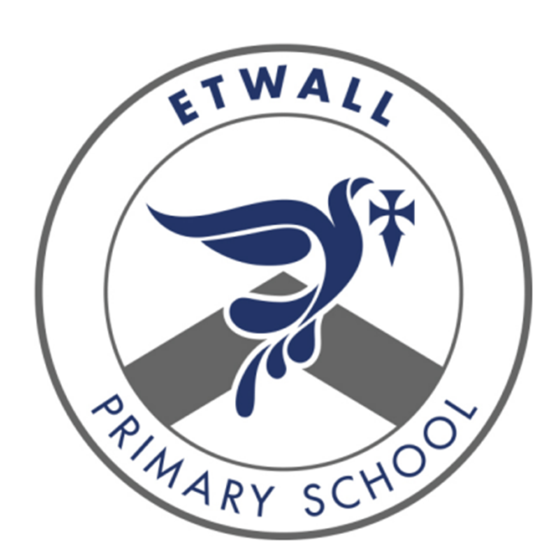

ETWALL PRIMARY SCHOOL
Maths Policy

Introduction

This document is a statement of the aims, principles, strategies and procedures for
mathematics throughout the school. This Policy document describes the strategy agreed by Etwall Primary School Governing Body for the delivery of maths. It should be read in conjunction with the intent, implementation and impact statement for maths, and the calculation policy.

The aims of the 2014 National Curriculum are for our pupils to:

• Become fluent in the fundamentals of mathematics through varied and frequent practice with complexity increasing over time.
• Develop conceptual understanding and ability to recall and apply knowledge rapidly and accurately.
• Reason mathematically; follow a line of enquiry, conjecture relationships and generalisations.
• Develop an argument, justification and proof by using mathematical language.
• Problem solve by applying knowledge to a variety of routine and non-routine problems. Breaking down problems into simpler steps and persevering in answering.

The National Curriculum sets out year-by-year programmes of study for key stages 1 and 2. This ensures continuity and progression in the teaching of mathematics.

The EYFS Statutory Framework 2021 sets standards for the learning, development and care of children from birth to five years old and supports an integrated approach to early learning. This is supported by the ‘Development Matters’ non-statutory guidance. In relation to mathematics, aims for our pupils to:

· develop and improve their skills in counting
· understand and use numbers
· calculate simple addition and subtraction problems
· describe shapes, spaces, and measures

The Early Learning Goals

Number: Children at the expected level of development will: - Have a deep understanding of number to 10, including the composition of each number; 14 - Subitise (recognise quantities without counting) up to 5; - Automatically recall (without reference to rhymes, counting or other aids) number bonds up to 5 (including subtraction facts) and some number bonds to 10, including double facts.

‘Numbers: children count reliably with numbers from 1 to 20, place them in order and say which number is one more or one less than a given number. Using quantities and objects, they add and subtract two single-digit numbers and count on or back to find the answer. They solve problems, including doubling, halving and sharing.’ For this reason, we teach the children their numbers in stages, beginning with a focus on numbers to five. Children will understand the sequence of numbers, how to count up and down in steps of one, how to match them to their respective amounts, one more than and one less than, recognising an amount without counting to five quickly (known as subitising) Children will use a variety of apparatus to achieve this including everyday objects, counters, dice, cubes, number frames (ten frames) Numicon, pictures, and number tracks.

Numerical Patterns: Children at the expected level of development will: - Verbally count beyond 20, recognising the pattern of the counting system; - Compare quantities up to 10 in different contexts, recognising when one quantity is greater than, less than or the same as the other quantity; - Explore and represent patterns within numbers up to 10, including evens and odds, double facts and how quantities can be distributed equally.

The framework continues: ‘Shape, space and measures: children use everyday language to talk about size, weight, capacity, position, distance, time and money to compare quantities and objects and to solve problems. They recognise, create and describe patterns. They explore characteristics of everyday objects and shapes and use mathematical language to describe them.’ Through a rich, varied enquiry approach with child-initiated learning, children will explore everyday objects and contexts to support shape, space and measures and will be taught the language of these concepts.

The intent of mathematics in our school is to develop:

At Etwall Primary School, we believe mathematics is an important part of children’s development throughout school, right from an early age. We intend on delivering a curriculum which:
- allows children to become fluent in the fundamentals of mathematics through creative and engaging lessons that give them a range of opportunities to explore mathematics.
- Develops conceptual understanding and the ability to recall and apply knowledge fluently and rapidly.
- gives children opportunities to reason and problem solve by applying mathematics to a variety of increasingly complex challenges.
- Ensures children believe in themselves as mathematicians and develop resilience and perseverance that enables all children to reason and problem solve with increased confidence.
- builds upon children’s knowledge and understanding starting from the EYFS Framework and following into the National Curriculum, from Year One to Year Six.

Teachers planning and organisation

Long term planning

The National Curriculum for Mathematics 2014, Development Matters and the Early Learning Goals (Number, Numerical Patterns) provide the long-term planning for mathematics taught in the school.

Medium term planning

EYFS through to Year Six, use the White Rose Maths schemes of learning as their medium-term planning documents. These schemes provide teachers with exemplification for maths objectives and are broken down into fluency, reasoning and problem solving, key aims of the National Curriculum and EYFS Framework. They support a mastery approach to teaching and learning and have number at their heart. They ensure teachers stay in the required key stage and support the ideal of depth before breadth. They support pupils working together as a whole group and provide plenty of time to build reasoning and problem-solving elements into the curriculum.

Short term planning

The above schemes of learning support daily lesson planning. Lessons are planned and are monitored at intervals by the mathematics subject leader. All classes have a daily mathematics lesson where possible. In addition to this, EYFS and Key Stage One have a daily 15-minute Rekenrek fluency session, where possible and Key Stage Two have a 15-minute daily fluency session, again where possible.

In Key Stage One and Two, lessons are 60 mins long. The staff in EYFS ensure the children learn through a mixture of adult-led activities and child-initiated activities both inside and outside of the classroom. EYFS have two full mornings of mathematics a week. Mathematics is taught through an integrated approach.

Special educational needs & disabilities (SEND)

Daily mathematics lessons are inclusive to pupils with special educational needs and disabilities. Where required, children’s IEPs incorporate suitable objectives from the National Curriculum for Mathematics or Development Matters and teachers keep these in mind when planning work. These targets may be worked upon within the lesson as well as on a 1:1 basis outside the mathematics lesson. Maths focused intervention in school helps children with gaps in their learning and mathematical understanding. These are delivered by trained support staff and overseen by the SENCO and/or the class teacher.

Within the daily mathematics lesson teachers have a responsibility to not only provide scaffolded activities to support children with SEND but also activities that provide sufficient challenge for children who are high achievers. It is the teachers’ responsibility to ensure that all children are challenged at a level appropriate to their ability.

Inclusion

We aim to meet the needs of all, considering gender, ethnicity, culture, religion, language, disability, sexual orientation, age and social circumstances. Opportunities for scaffolding will be planned for less able pupils and opportunities for the more able at the short-term planning stage.

Lessons

The emphasis in lessons is to make teaching interactive and lively, to engage all children encouraging them to talk about mathematics. Lessons involve elements of:

- Instruction – giving information and structuring it well;
- Demonstrating – showing, describing and modelling mathematics using appropriate resources and working walls;
- Explaining and illustrating – giving accurate and well-paced explanations;
- Questioning and discussing;
- Consolidating;
- Reflecting and evaluating responses – identifying mistakes and using them as positive teaching points;
- Summarising – reviewing mathematics that has been taught enabling children to focus on next steps

Pupils’ Records of work

Children are taught a variety of methods for recording their work and are encouraged and helped to use the most appropriate and convenient. Children are encouraged to use mental strategies and their own jottings before resorting to more formal written methods, detailed in the calculation policy. Children’s own jottings to support their work is encouraged throughout all year groups.

Marking

Work is marked in line with the school marking policy. Children are encouraged to self-assess their work, where appropriate, and given time to make corrections or improvements. Responses to marking are made in purple pen as close to the work as possible, ideally at the start of the next lesson. Some pieces of work in mathematics can be marked by children themselves, exercises involving routine practice with support and guidance from the teacher – particularly in Key Stage Two.

Assessment

Assessment is an integral part of teaching and learning and is a continuous process.

Short Term
Teachers make assessments of children daily through:
- regular marking of work
- analysing errors and picking up on misconceptions
- asking questions and listening to answers
- facilitating and listening to discussions
- making observations

These ongoing assessments inform future planning and teaching. Lessons are adapted readily and short-term planning evaluated considering these assessments.

Medium term
Termly assessments are carried out across the school using the assessment materials for each year group provided by NFER, NTS and a range of other sources.

Long term
Y2 and Y6 complete the national tests (SATs) in May. Years 1, 3, 4 and 5 continue to use the NFER, NTS tests, which inform teacher summative judgements in the Summer Term.

Resources

Each class has a stock of core resources that are age appropriate. Additional mathematical equipment and resources are stored centrally in the resources room.

Home/School Link

The link between home and School is forged in a number of ways. This will support the mathematics work in the classroom. To give more detailed outlines of the child’s progress, annual reports and twice yearly, formal meetings are arranged, but informal meetings are encouraged, when needed. The school also offers a calculation policy which explains the methods the children will be taught at school. The calculation policy is available on the school website.

Role of the Maths Subject Leader

- To lead in the development of maths throughout the school.
- To monitor the planning, teaching and learning of mathematics throughout the school.
- To help raise standards in maths.
- To provide teachers with support in the teaching of mathematics.
- To provide staff with CPD opportunities in relation to maths within the confines of the budget and the School Improvement Plan
- To monitor and maintain high quality resources.
- To keep up to date with new developments in the area of mathematics.

